Use Case Diagram:

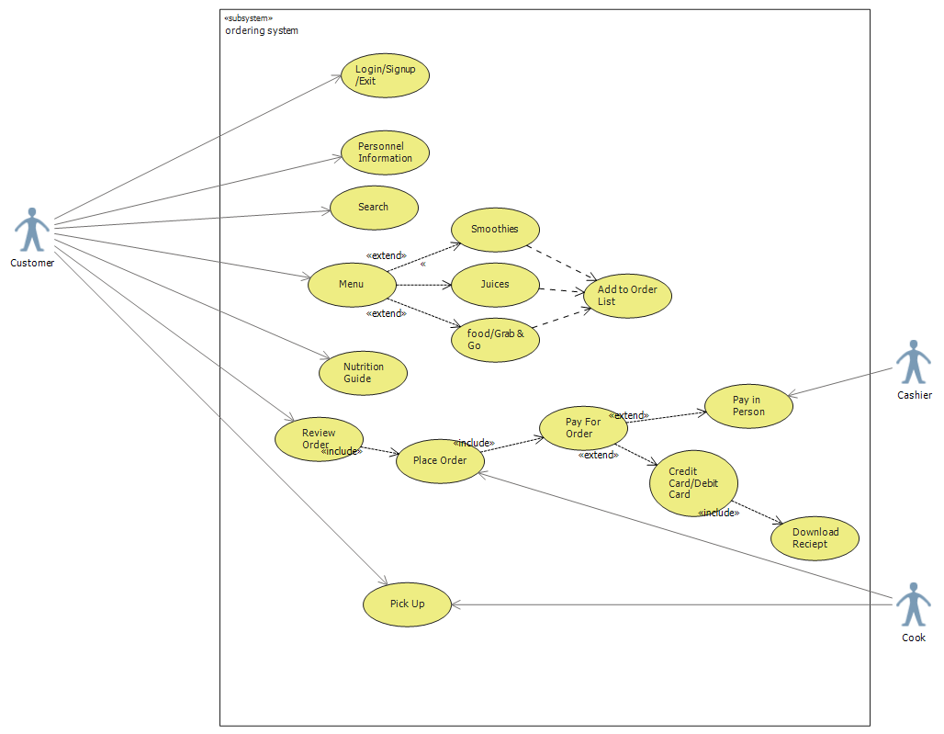

Use Case Description:

|  |
| --- |
| Use Case Title: login/signup |
| Primary Actor: Customer |
| Level: Sea Level |
| Stakeholders: Customer |
| Precondition: User downloads the app and must be online with web access |
| Minimal Guarantee: Rollback of any uncompleted transactions |
| Success Guarantee: User is registered, and all information is updated |
| Trigger: Customer access the homepage |
| Main Success Scenario:  1.Customer is asked to login.  2.If customer is a new user, user can create an account.  3.If customer has already an account, they can fill in the username and password, and the menu appears.  4.If they are a new user, they can create an account by choosing a username and password.  5.User can click on “help” if they need.  6.User is also given an option to sign up with “Google” or “Facebook” account.  7.Then, a user is prompted to provide their email, phone number, name and other details.  8. A page appears asking user to register loyalty card (Points card) if they have else purchase a card.  9.User can skip this page and then the menu appears with other options in it. |
| Extensions:  1.a. Customer gets error while loading.  1.a.1. Customer gets “Page not found” error.  1.a.2. Customer hits the ‘Refresh button’ and the page loads successfully.  1.a.3. Customer hits ‘Refresh button’ and could not load page.Customer leaves the app.  3.a. Customer gets message “Invalid Username or Password”.  3.a.1. Customer refreshes and try again. Attempt successful.  3.a.2. Customer hits ‘Forget password ‘and gets a mail or text to reset password. Customer logins successfully.  4.a. Customer gets “Username already exists”.  4.a.1. Customer tries a different username.  7.a. Customer gets “invalid phone number”  7.a.1 Customer tries again and successfully proceeds. |